NEXTAG COMPANY

**Saffiano leather clutch**

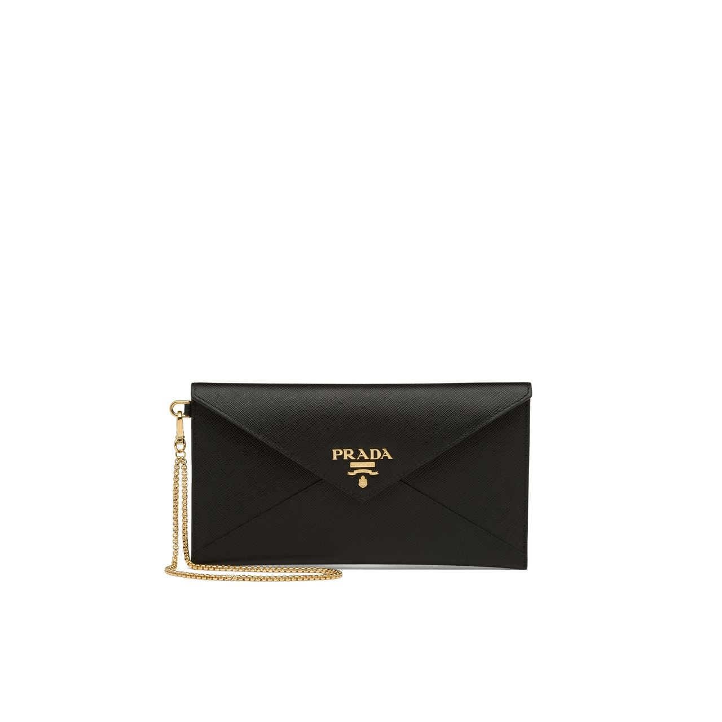

Style # 1MV204_2CDM_F0YQY

440 $

product details

Saffiano leather  
Detachable metal chain  
Snap closure  
Rear pocket with heart-shaped charm on zipper pull  
Nappa leather lining  
11 cm height  
20 cm width